aggregate function ---it runs on group of rows

max(),min(),avg(),count(),sum()

group by

having

100

select sum(sal),max(sal),min(sal),avg(sal),count(*)

from emp;

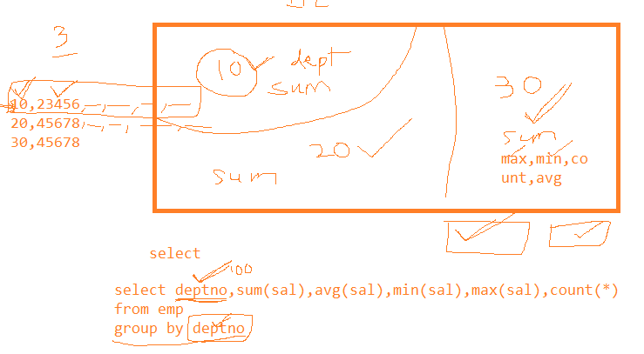

--------rules

1. add only columns in select statement along with aggregate function which are used in group by clause
2. count(*) will count all rows along with null values
3. count(col name) will not count null values, but will count only not null values.
4. if you want to filter data based on aggregate function then use having clause

--------display sum of salary for each department

select depno,sum(sal),max(sal),min(sal),avg(sal),count(*),count(comm)

-> from emp

-> group by deptno;

------count how many employees in each designation, and display only there are more than 2 employees of each designation

select job,count(job)

-> from emp

-> group by job

-> having count(job) > 2;

-----display all departments which has more than 2 manager

select deptno,count(job)----------5

from emp--------🡪1

where job='MANAGER' --------🡪 2

group by deptno ------🡪3

having count(job) >2; --------4

-------display max,min,avg of sal and count for all jobs in each department only if min(sal)>1500  
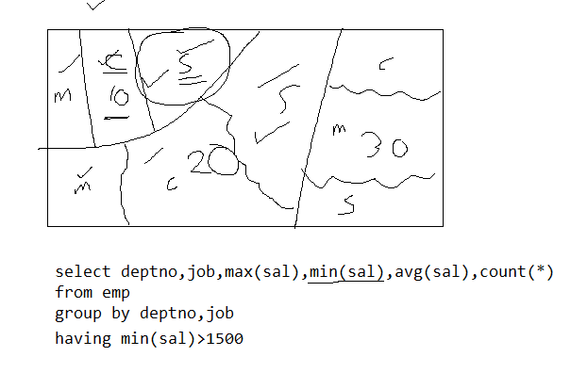

---------to find min,max of salary and number of people who are working under same manager

select mgr,sum(sal),max(sal),min(sal),count(*)

-> from emp

-> group by mgr;

------find how many analysts are working under each manager

select mgr,count(*)

from emp

where job=’analyst’

group by mgr;

--------display only department with avg sal >2500

select deptno,avg(sal)

from emp

group by deptno

having avg(sal)>2500;

-----display only jobs with min sal > 1500 an arrange data based min sal

select job,min(sal)

from emp

group by job

having min(sal)>1500

order by min(sal);

-------- product

pid pname qty price catid salid

1 lays 34 40.00 1 100

3 pringles 100 100.00 1 101

4 nachos 450 250.00 1 102

--------- find sum of price for all products sold by each salesman

select salid,sum(price)

from emp

group by salid

------ find how many products in each category with price >40

display only categories which has more than 2 products

select catid, price, conut(*)

from product

where price>40

group by catid

having count(*)>2;

------distinct keyword

----to display different values of manager column

select distinct mgr

-> from emp;

-------to display different jobs in emp table

select distinct job

-> from emp;

---------- to find all employees whose name starts with A

select *

from emp

where ename like ’A%’

---------- to find all employees whose name starts with A and L at third position

select *

from emp

where ename like ’A_L%’

------------to find name start A ends with N and Lany where

select *

from emp

where ename like ’A%L%N’

select *

from emp

where ename REGEXP ’^A.*L.*N$’

------to find all names which has ma

select *

from emp

where ename REGEXP ‘^A.*ma.*n$’

---------------------to display data along with thousand separator

1,23,456.3456767

select empno,format(price,2)

---------------------to display data along with thousand separator and currency sumbol

select concat('$',format(sal,2))

-> from emp;

------- case statement

sid sname marks

1 aaaa 80

2 bbbb 70

3 ccc 60

select sid,sname,marks,case when marks>70 then “distinction”

when marks <=70 and marks>= 60 then “first class”

else “second class” end

from emp

select empno,ename,deptno,case deptno when 10 then 'HR'

-> when 20 then 'purchase'

-> when 30 then 'sales'

-> else 'Accounts' end “grade”

-> from emp;

or

select empno,ename,deptno,case when deptno=10 then 'HR'

-> when deptno=20 then 'purchase'

-> when deptno=30 then 'sales'

-> else 'Accounts' end “grade”

-> from emp;

-------display

low sal < =1500

medium sal >1500 and <2500

high sal otherwise

select empno,ename,sal,case when sal<=1500 then ‘low sal’

when sal between 1499 and 2499 then ‘medium sal’

else ‘high sal’ end “remark”

from emp;

example

+------+---------------+------+--------+------+

| pid | pname | qty | price | cid |

+------+---------------+------+--------+------+

| 2 | Nachos123 | 302 | 150.00 | 1 |

| 3 | Pringles123 | 12 | 150.00 | 1 |

| 4 | Marie gold | 20 | 50.00 | 2 |

| 5 | nice1234 | 35 | 45.00 | 2 |

| 6 | good day123 | 45 | 60.00 | 2 |

| 20 | Hide and seek | 45 | 40.00 | 2 |

| 123 | sfgdfg | 45 | 123.00 | 3 |

+------+---------------+------+--------+------+

if price < 100 good  
else if price>= 100 and < 149 ok

otherwise expensive

select pid,pname,price,case when price <100 then "good"

when price between 100 and 149 then "ok"

else "expensive" end "Remark"

from product

--------if

cid =1 chips

cid=2 biscuites

3 snaks

otherwise

general

select pid,pname,price,cid,case when cid=1 then 'chips'

when cid=2 then'biscuites'

when cid=3 then 'snacks'

else 'general' end 'Category'

from product;

or

select pid,pname,price,cid,case cid when 1 then 'chips'

when 2 then'biscuites'

when 3 then 'snacks'

else 'general' end 'Category'

from product;

---------- select all employee with salary > 1500

select *

from emp

where sal>1500;

subqueries

when output of one query is based on output of another query then use nested query

------inner query will get executed first and only once for all will give use value for executing other r query

--------display all employees with sal > jones sal

select empno,ename,sal

from emp

where sal > (select sal

from emp

where ename='JONES' )

--select all employees who are working in same department where ALLEN is working

select *

from emp

where deptno= (select deptno

from emp

where ename=’ALLEN’ )

------display all employees with sal > either ALLENs sal or SMITH’s Salary

select *

from emp

where sal > any (select sal

from emp

where ename in ('ALLEN' ,'MILLER') )

select *

from emp

where sal > any (select sal

from emp

where ename = 'ALLEN' )

union

select *

from emp

where sal > any (select sal

from emp

where ename = 'MILLER' )

---- to find all employees who are working under same manager as JONES

select ename

from emp

where mgr = (select mgr

from emp

where ename=’JONES’)

----------- display all employees whose sal > min sal of dept 20

select *

from emp

where sal >(select min(sal)

from employee

where deptno =20)

----------- display all employees whose sal > min sal of employees own dept

------inner query is dependent on parent query hence this is called as correlated query

------- inner query will get executed once for each row

select *

from emp e

where sal > ( select min(sal)

from emp s

where s.deptno=e.deptno)

-------select all employees whose sal is > its own manager’s salary

select empname,empno

from emp e

where sal > (select sal

from emp m

where m.mgr=e.mgr)

------ list all products whose price is > than min prices its own category

select pid,pname,price

from product p

where price > (select min(price)

from product p1

where p1.cid= p.cid);